Fall 2022

Car Rental Website

|  |  |
| --- | --- |
| Name | ID |
| Ahmad Hazem Ahmad | 7193 |
| Mohammed Ahmed Saleh | 7004 |
| Amr Ahmed Mousa | 6798 |
| Nader Mohammed | 7115 |

Contents

1.0 ER Diagram and schema 2

2.0 USER MODE 3

2.1 home page 3

2.2 Login pAGE 3

2.3 SIGN-UP pAGE 4

2.4 Profile Page 4

2.6 reserve Page 5

2.7 View user reservations 6

3.0 Admin MODE 7

3.1 Veiw reservations during specfic period 7

3.2 View all cars or a specfic car 8

3.3 View Car status 9

3.4 View Customer reservations by name 10

3.5 add CAR 12

3.6 Customize car 13

3.7 Delete CAR 15

3.8 Payments 16

3.9 Adding branches 18

# ER Diagram and schema

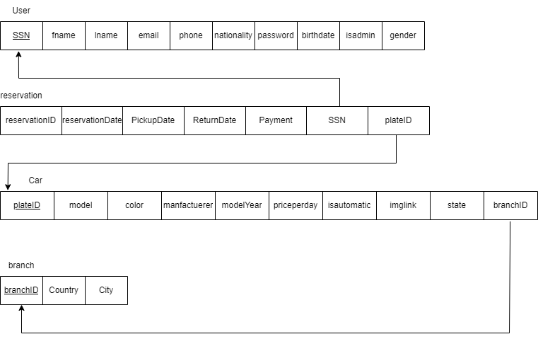

# 2.0 USER MODE

## 2.1 home page

Our home pages



## 2.2 Login pAGE

This is the login page the user can log in if he/she has an account otherwise sign up for a new account.

## 2.3 SIGN-UP pAGE

This is our sign-up page for our website here the user must fill up that form to obtain an account.

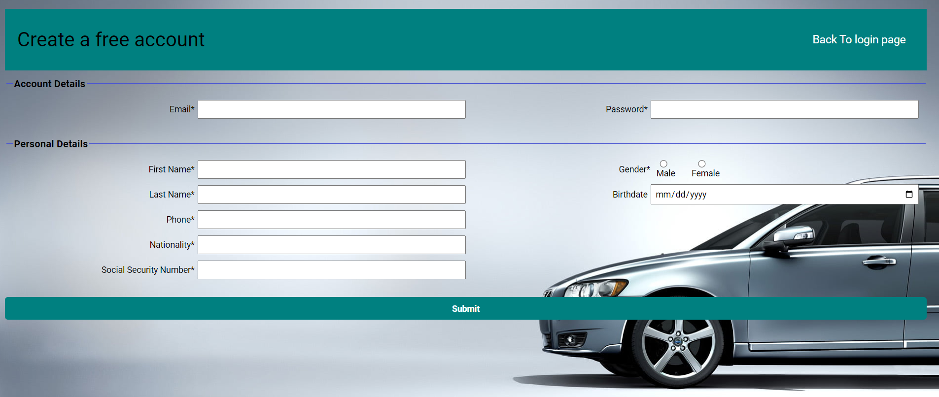

## 2.4 Profile Page

This is the user’s profile page that contains all his login information

The user here can either click back to log out or reserve car to reserve car in the reserve page or view his previous reservations and due payments.

Also he can delete his account with the button below his information

## 2.6 reserve Page

Here we can see the reservation page where the user can put the period he needs to reserve the car and the location branch. There are extra search filter to aid him/her in his search such as car brand/manufacturer or car model or color or max price.

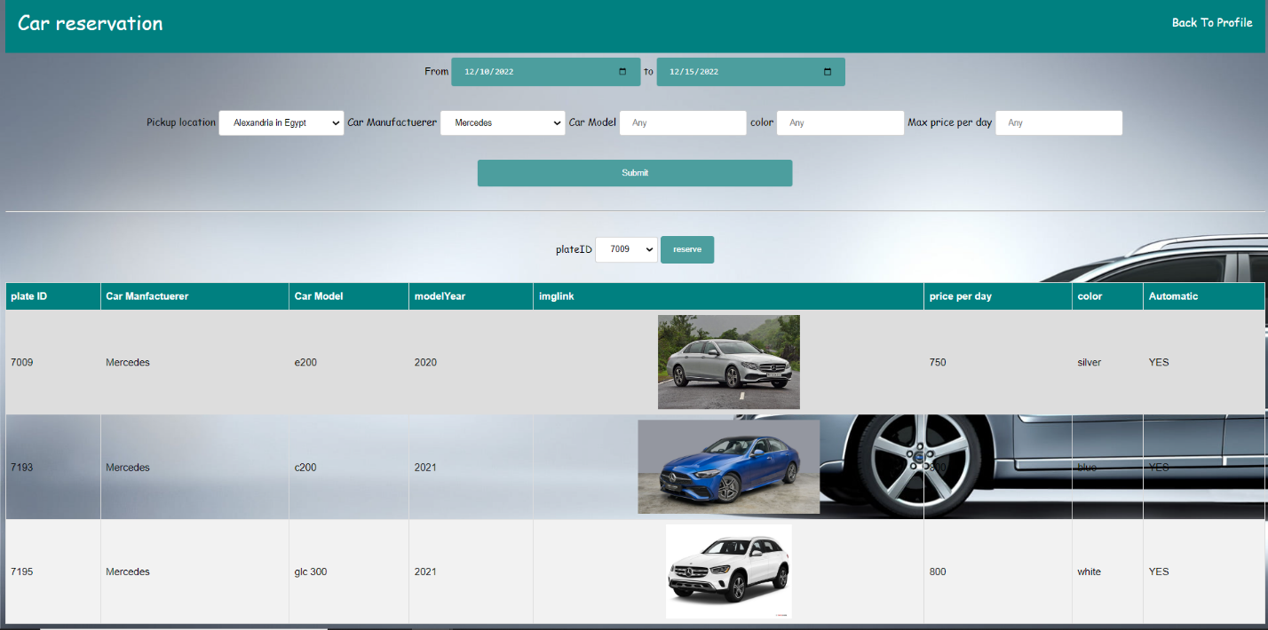

For this example, the user has entered the period that the car will be reserved in and chose Alexandria branch and wanted to reserve Mercedes cars.

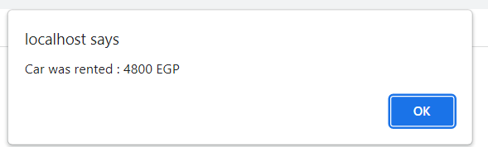To complete reservation user must click reserve.

## 2.7 View user reservations

Here the user can observe all of his reservation and delete a reservation if he/she wants by inserting it in the above form.

# 3.0 Admin MODE

## 3.1 Veiw reservations during specfic period

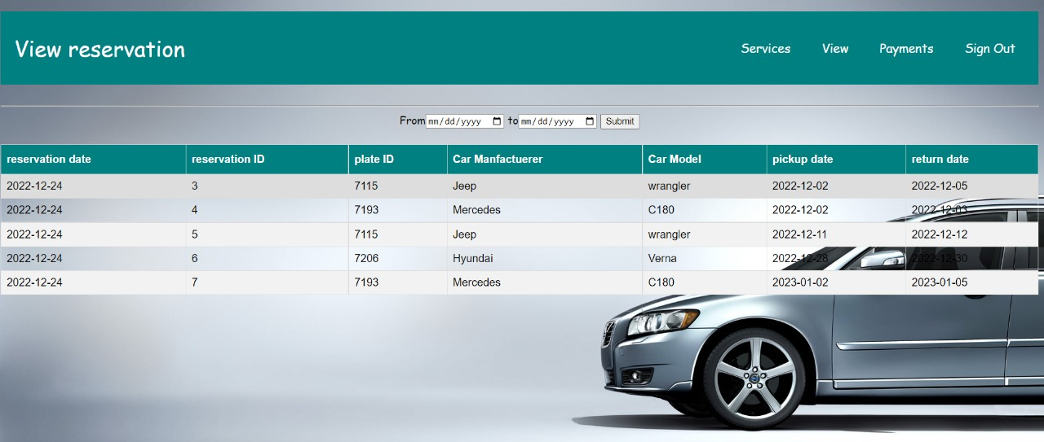If the ADMIN wishes to know ALL the cars which is reserved in the agency he/she can find “view reservation” page which Displays it ( figure shown below )

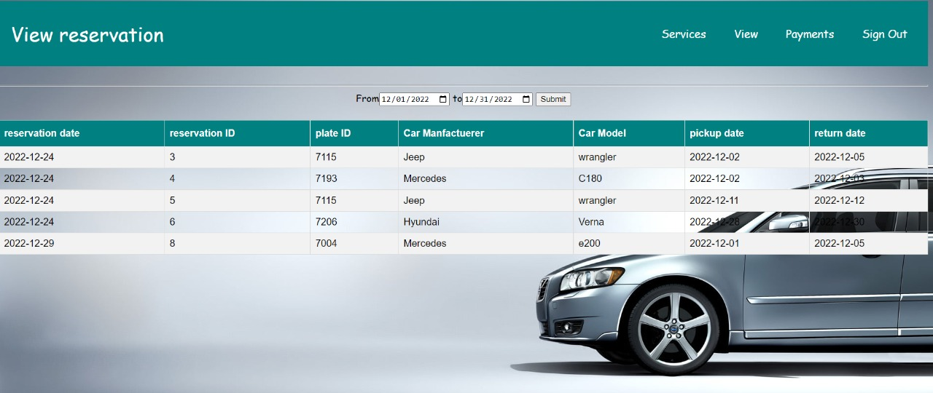In Case of the ADMIN wants to search for a specific car to check its reservation information he/she can search for the car by inserting the range of the date to show all the cars with there pickuo date and return date which is in the given range by the ADMIN

## 3.2 View all cars or a specfic car

This is a view of All the cars which is in the agency

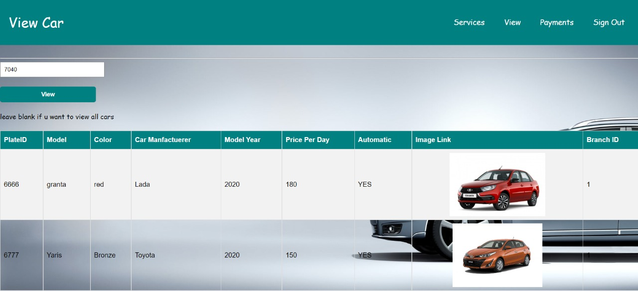

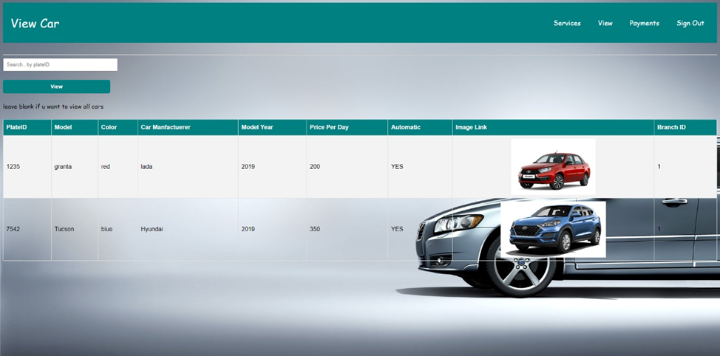

When the ADMIN wants to search for a specific car he/she can search for the car by inserting its plateID in the space provided

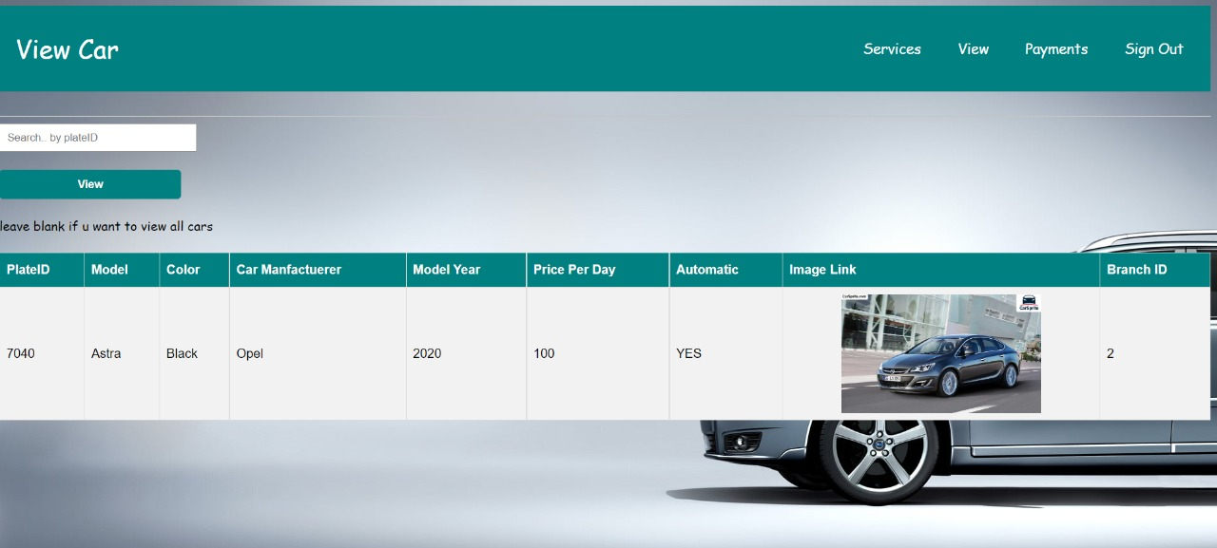( In this example a search for a car with plateID🡪 7040 has been made )

## 3.3 View Car status

In this page A view of the cars status which shows All the cars with its states ( Active OR out of service )

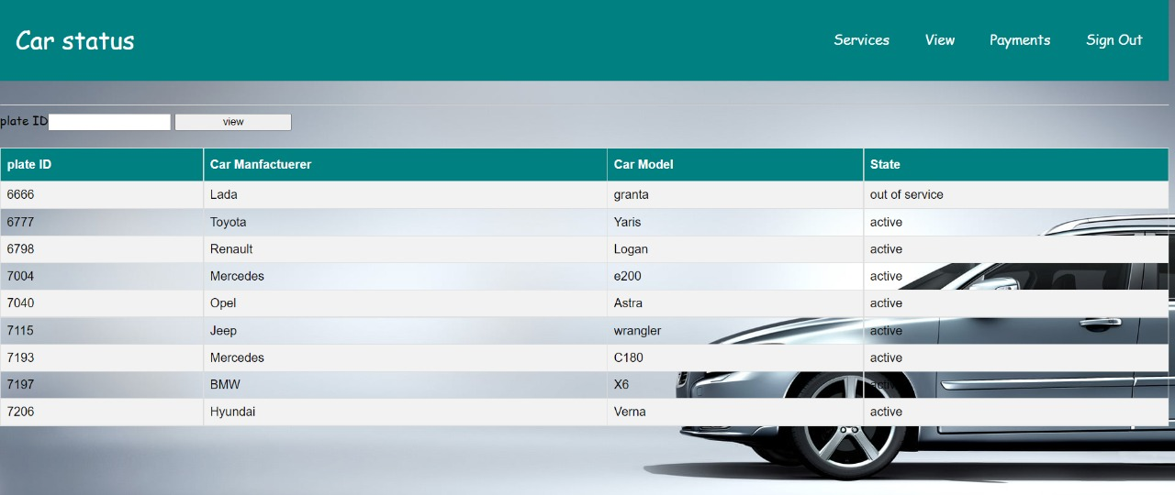

If the ADMIN wishes to search for a specific car to check its current starus , he/she can search for the car by inserting its PlateID

( In this example a search for a car with plateID🡪 7004 has been made to check its status , which is shown in the below figure )

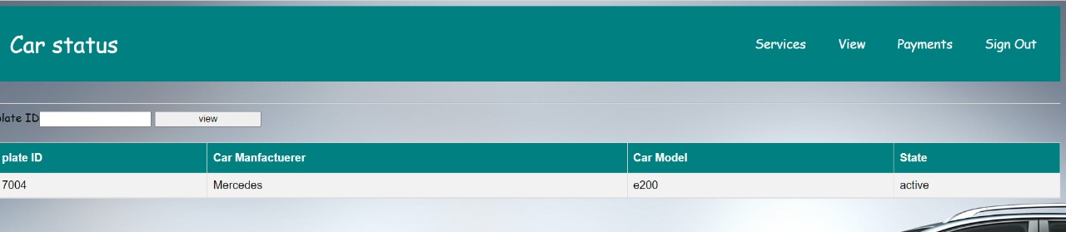

## 3.4 View Customer reservations by name

A Customer Reservation page which views all the customers and the car specification which is reserved by its member displayed as in the figure below

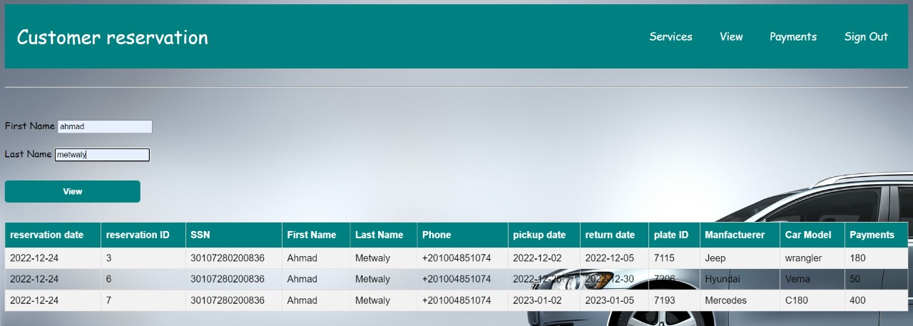

When the ADMIN wishes to view the information of a specific customer dealing with the agency and rented a car , he/she can search for the customer by searching for his/her name from the search box and press “View”

And then the customer will be displayed with his/her information

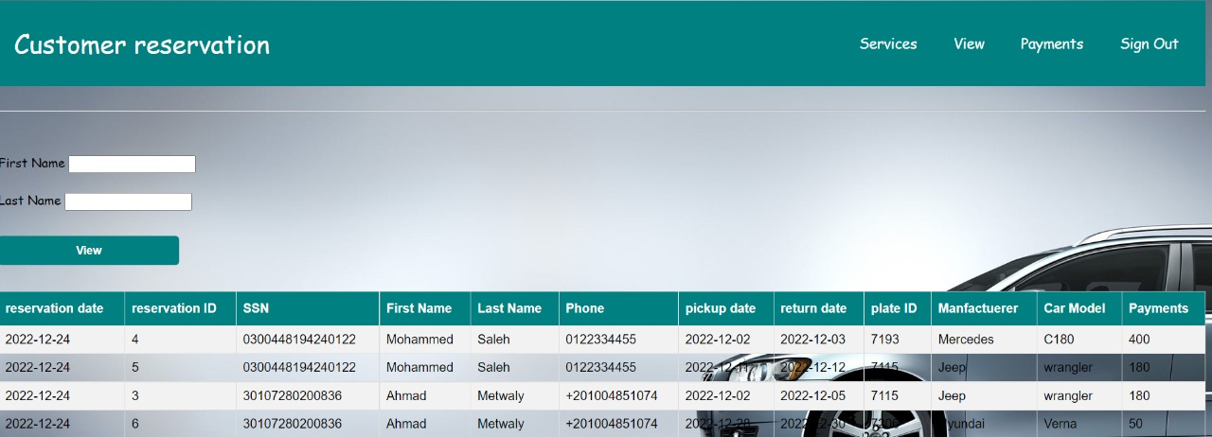

## 3.5 add CAR

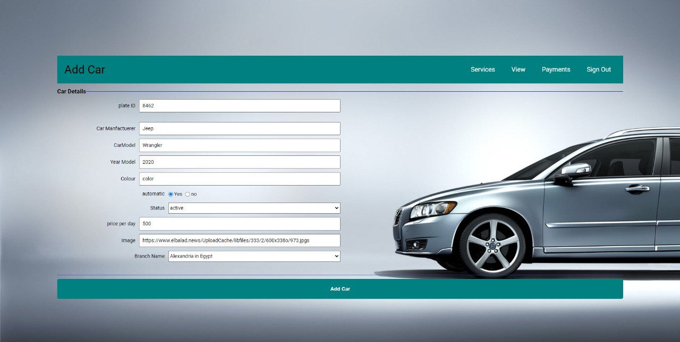

When the Admin wishes to add a new car to the agency, by going to the Adding car pages , and start inserting the specifications of the new car for insertion and

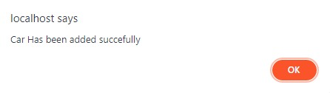

## 3.6 Customize car

When the Admin wishes to customize a specific identify for a car that exists in the agency, he/she have to insert the plateID of the car required to be altered as the shown figure below.

In this example The price of the car with plateID 🡪1235 ( Red lada ) price per day to be changed from 200 to become 400 per day and by which will be updated in the site once the Admin Apply his changes to the customization.

This a view list of the cars before any changes

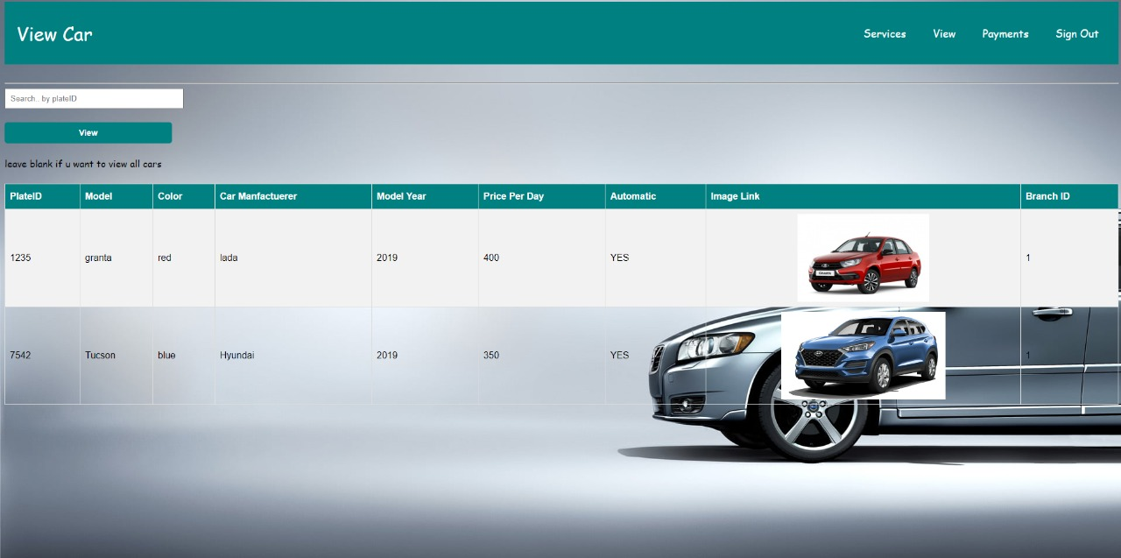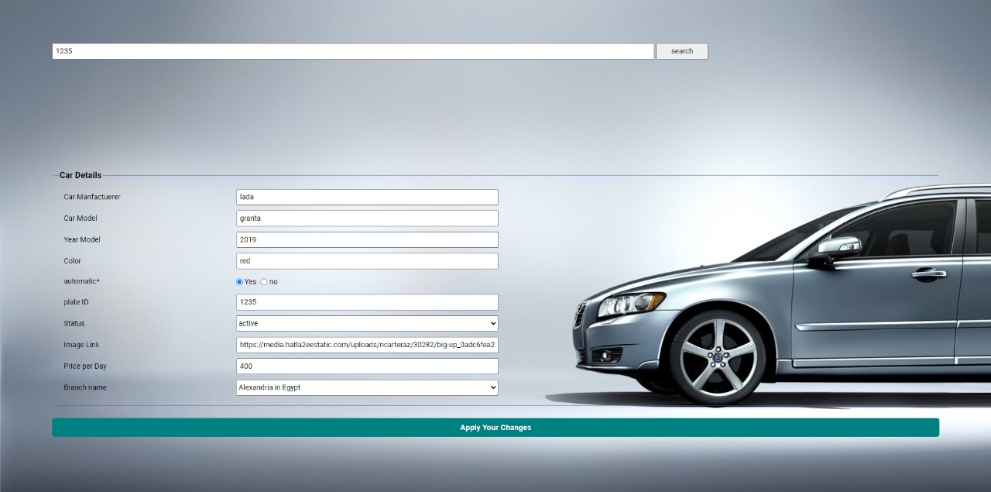

The new price of the car with plateID 🡪1235 after altering its price per day

## 3.7 Delete CAR

This is a an example of the lists of the car that exists in the Agency, before deleting a specific car

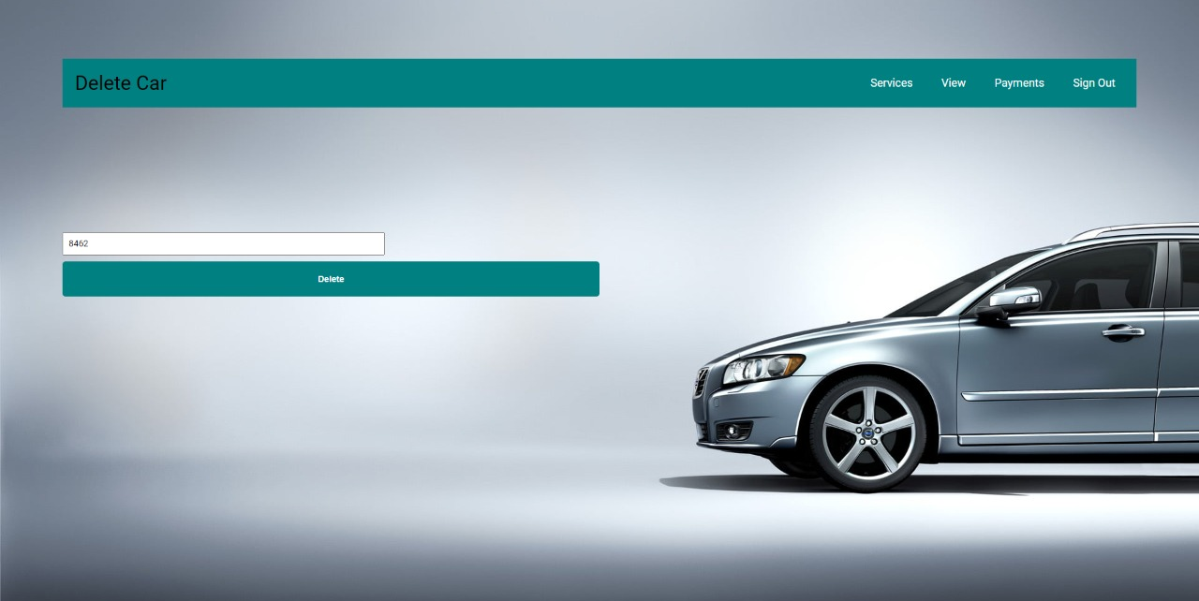Here we are Removing a car from the agency with plateID 🡪 8462 ( Jeep car )

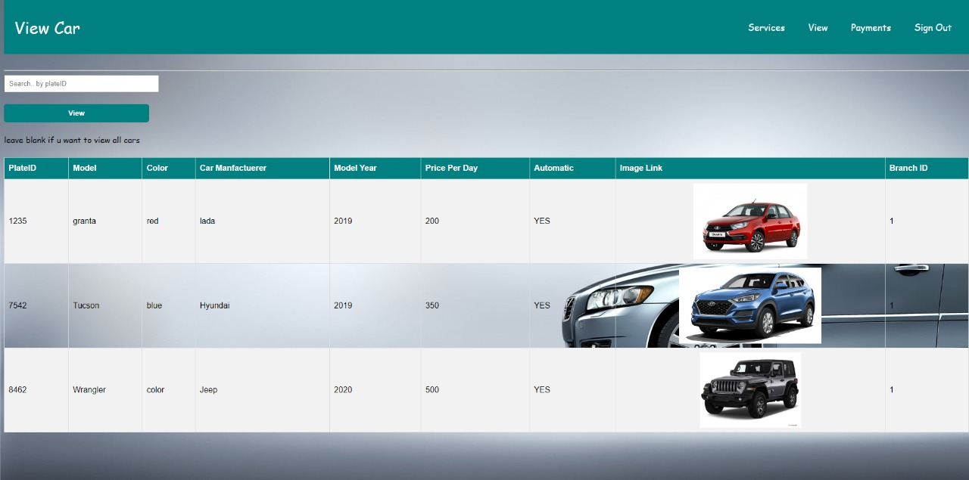

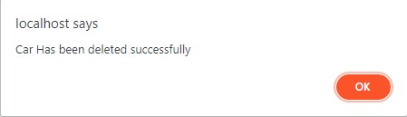

The car has been removed from the agency successfully and an updated list of the Avalible cars in the agency shown in the figure below

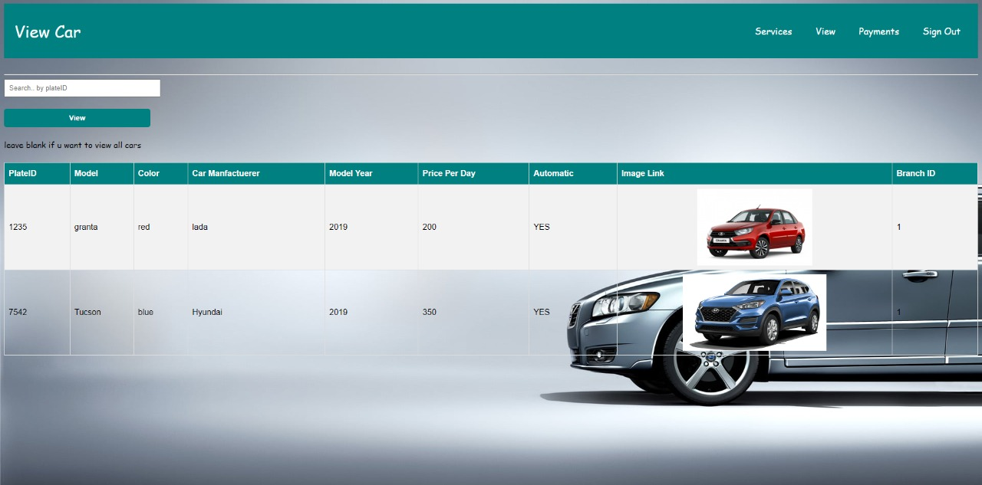

## 3.8 Payments

When the ADMIN wishes to know the profit which being made by the agency in a specific period

He/she should insert the range of the date, then the Total profit of the cars which is active in the agency

*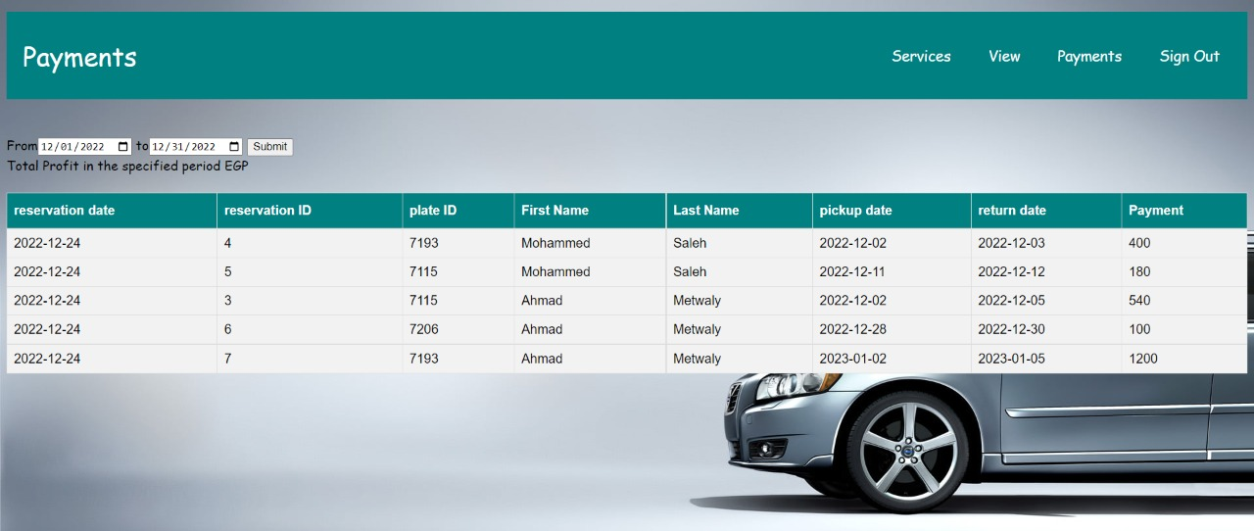Display of all the cars which is active with each price per day is shown*

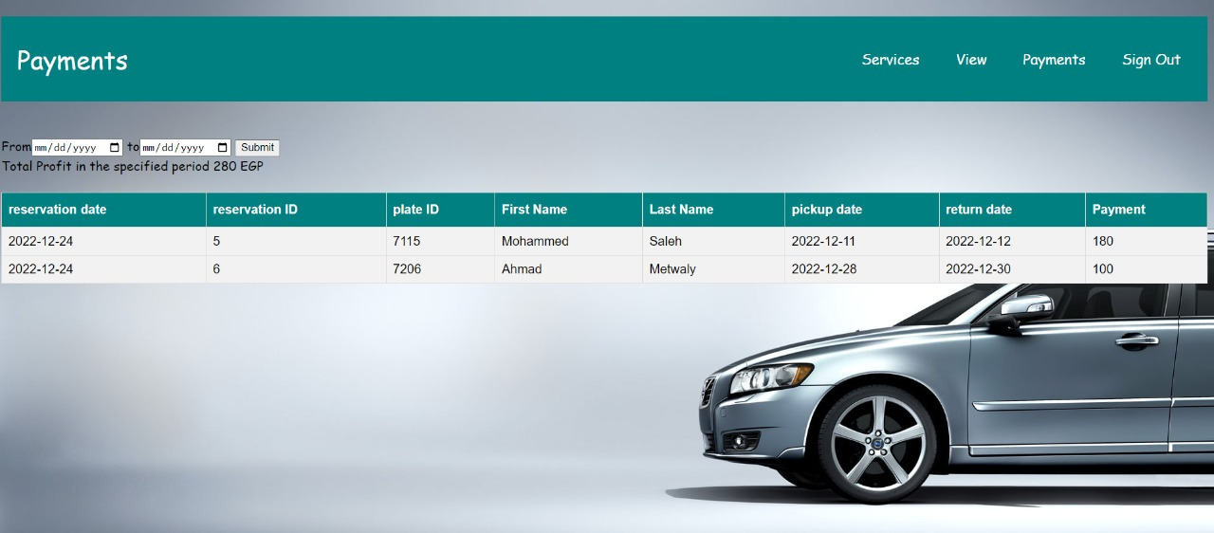The shown figure below shows all the cars in the specific period being searched for and The Total profit which is made by the agency

## 3.9 Adding branches

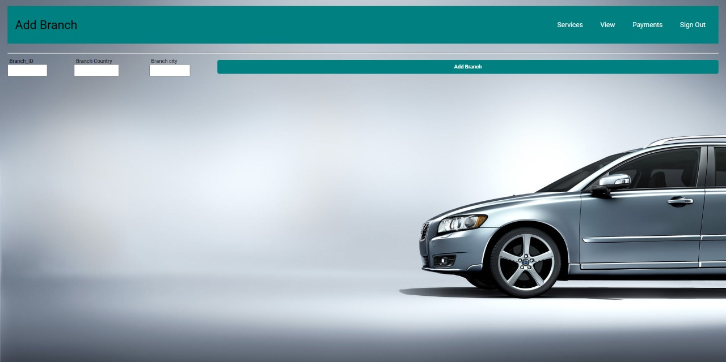

This is the available branches for which the ADMIN can select from when he/she adds a new car, before adding any new branches to the agency

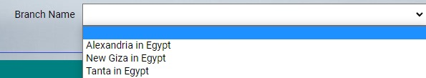

Insertion of the specifications of the new branch which will be added to the Agency

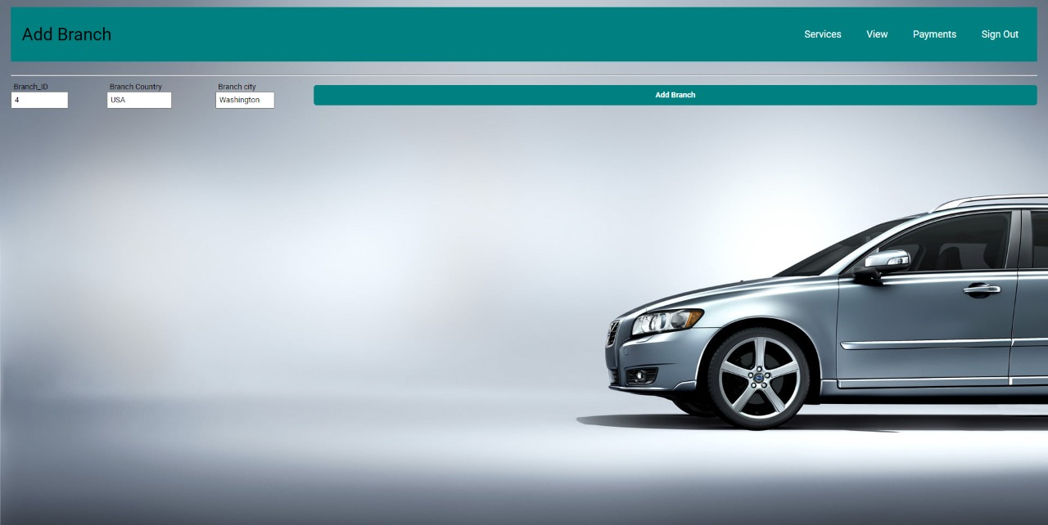

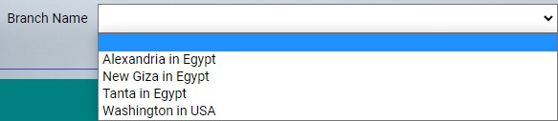The branches which will be available to the ADMIN when he/she wishes to add a new car to the agency

## 4.0 Viewing whole customers

Here whole customers in the system can be observed and even searched by name

